RELEASE 3: 10 WEEK 3 – Ecofire Pyro Stainless Steel Wood and Gas combo - Approved
SUBJECT: Unlimited Cooking Options this Braai Season
VIB: Braai in Style with Ecofire Pyro
Hi Fname,
Braai this season with the Ecofire Pyro Duel Fuel Braai.
Unlimited cooking options with our Dual Fuel braai options.
It can be considered sacrilege to watch the Boks play this World Cup without having a fire burning for a nice braai with family and friends.
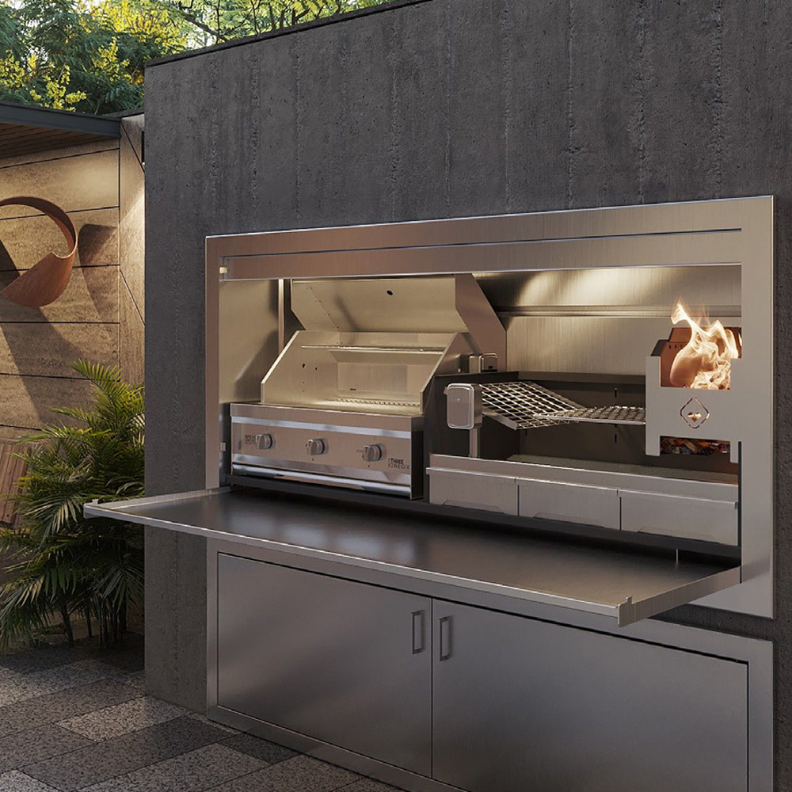
To savour each game this World Cup, you can now have unlimited cooking options with our dual fuel braai collection. This gives you the traditional feel of braaiing while saving on cooking time, so that the games can be enjoyed in all their glory. Redefine your game nights this braai season with the Ecofire Pyro Stainless Steel Wood and Gas Combo.

Are you worried about being braai and game ready for the weekend?
Installation is quick and effortless, saving you on building costs and time.
We offer 3 different steel options, making this braai suitable for both inland and coastal areas.


Whether you are masterminding a whole new dream entertainment area this braai season or it’s a case of out with the old and in with the new, finding the perfect braai has never been easier. With Ecofire, your wood and gas combo braai can be custom built to spec, kitted with a potjie hook for more cooking versatility and an easy access cleaning system. Talk to our team about elevating your entertainment area.

Are you tired of holding a torch over your braai at night?
The Ecofire Pyro comes with an in-built bright light for nighttime cooking, ensuring ease and perfection.
A spit grid rotisserie is included and accompanied by easy fit cantilevered multiple grids, giving unlimited cooking options for you to explore and enjoy.

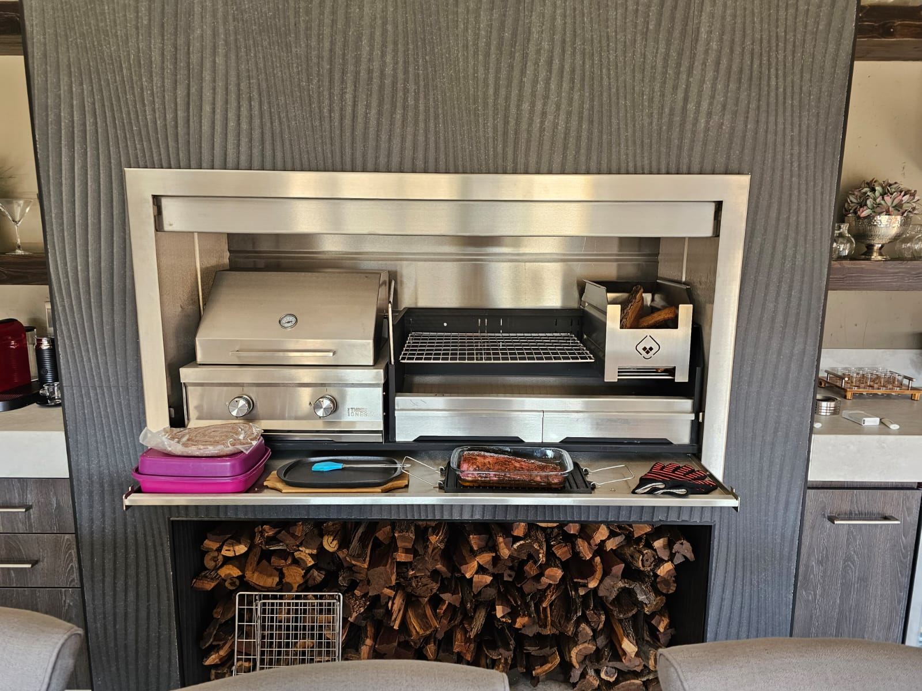

Our dual fuel braais are a fusion of style, technology, and functionality. Choose the ratio between wood and gas. Also available in single fuel full gas or full wood. The Pyro Range comes standard with our New Three One Six Bbq grill. Contact our Ecofire sales team to bring your unlimited cooking options dream to life.

